Boosting vs Bagging:
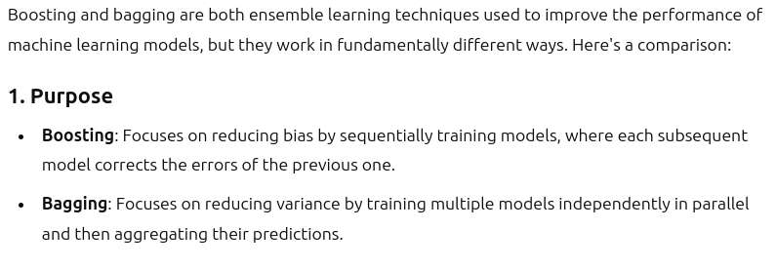

Since in bagging, the whole model is considered for evaluation(considered whole decision tree model), the variation is usually high.
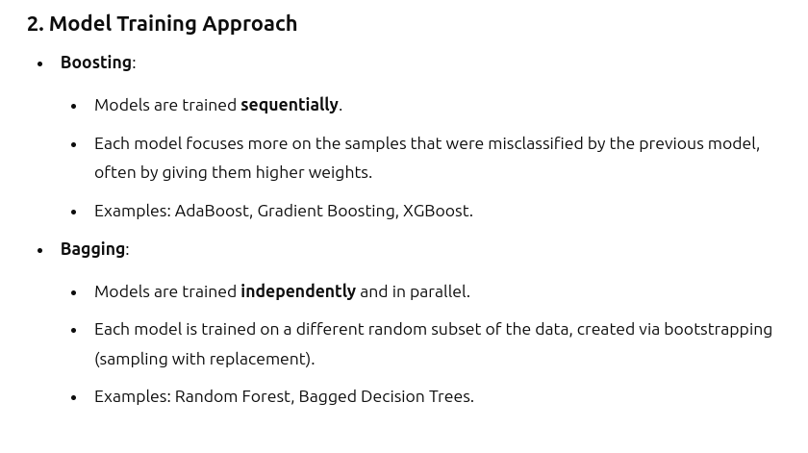
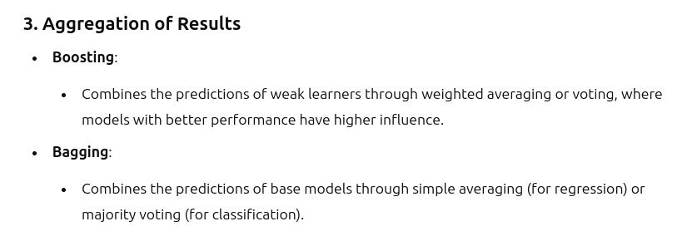
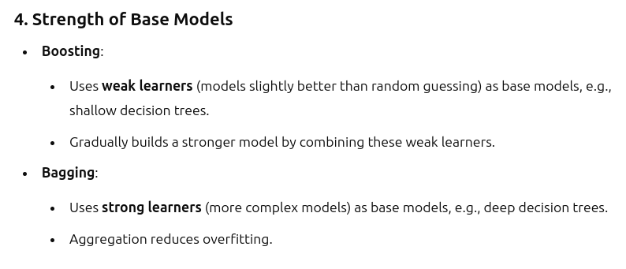
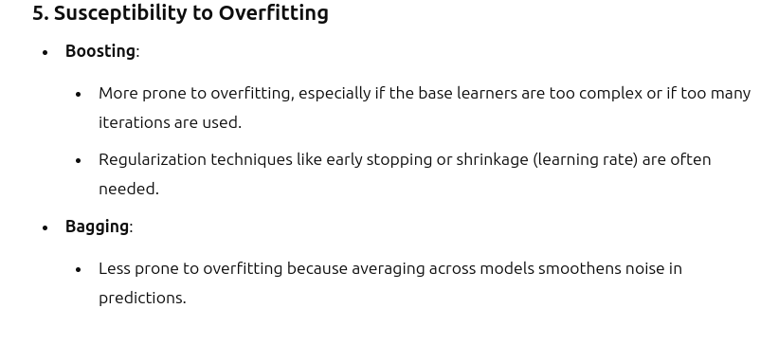
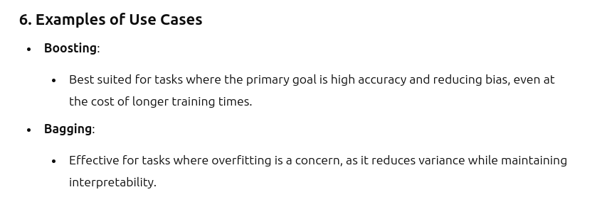
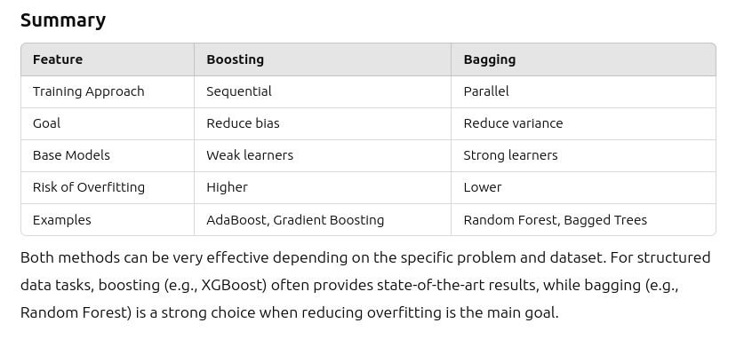
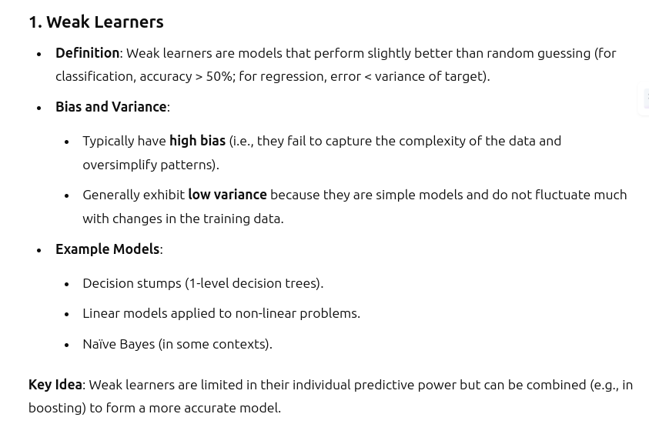
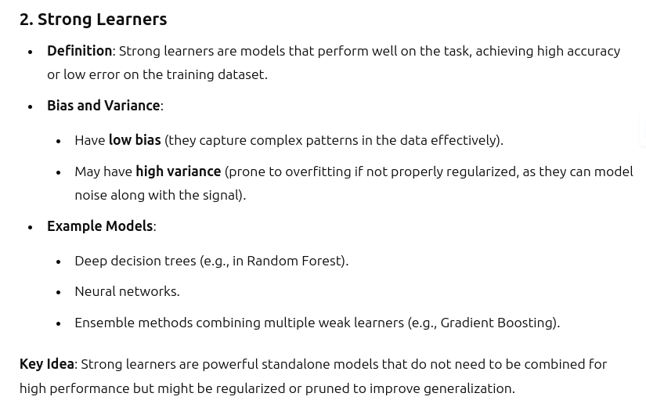
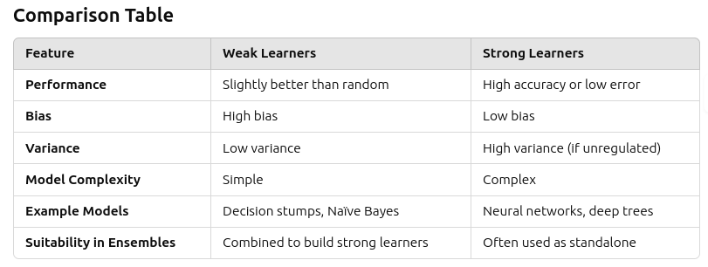
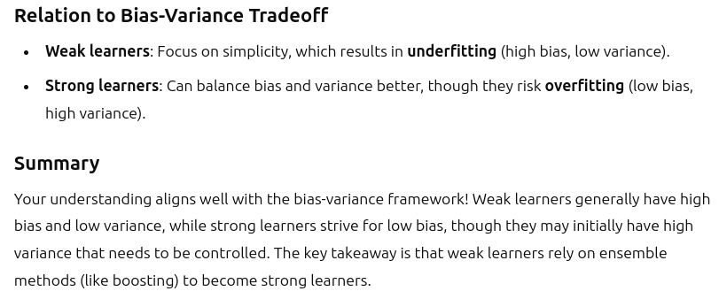

GRADIENT BOOSTING
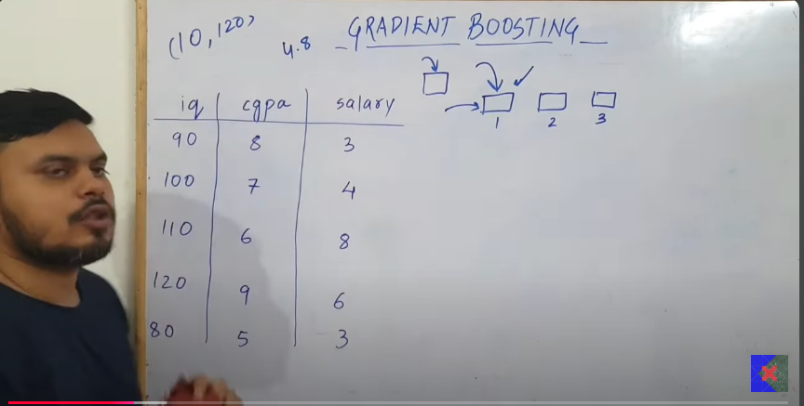

- Sequential stagewise addition: Each time a single model is produced, trained over the model, based on this next model is generated.
  - Upsamling : The problem in the previous models will be passed on it, so that in next model the training dataset focus on learnng the dataset with less errors, so this is how overal training errors are reduced. (ncrease weights on the error tarined data).

- Step1:
  - Model 1(Just the approximation):
  - Here we considered 3 models, just to undersatnd the problem.
  - In regression, the output is the mean is the output of the model(4.8 in this case).
  - 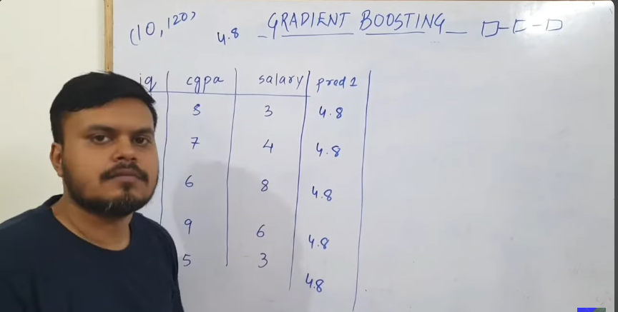
  - Actual - predicted = psuedo-residual , (actual - predicted)^2 , is the residual .
  - The error at model 1 to be propagated to model 2, from the research got to know that decision tree is best suited for the gradient boosting.
- For model 2(Decision tree): The inputs shall be iq and cgpa and the output is res1(residual 1).
  - Meaning: The error from the model 1 is passed on to the second model, and in the model 2 we focus on the predicting error from the model 1 using decision tree , the accuratley the error is predicted, with the same accuracy the salary is predicted.
  - 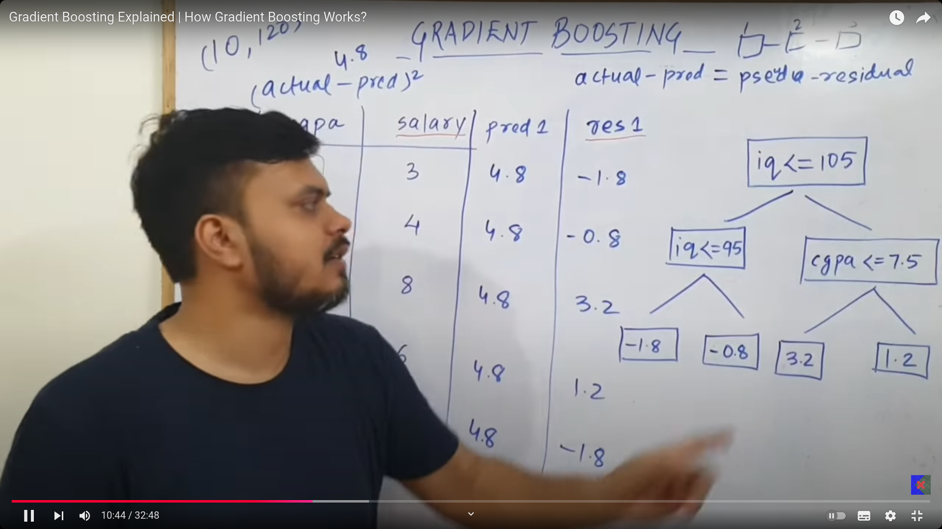
  - Above is the decision tree is found.
  - Now predict(pred) the output based on the inputs (iq and decision tree).
  - 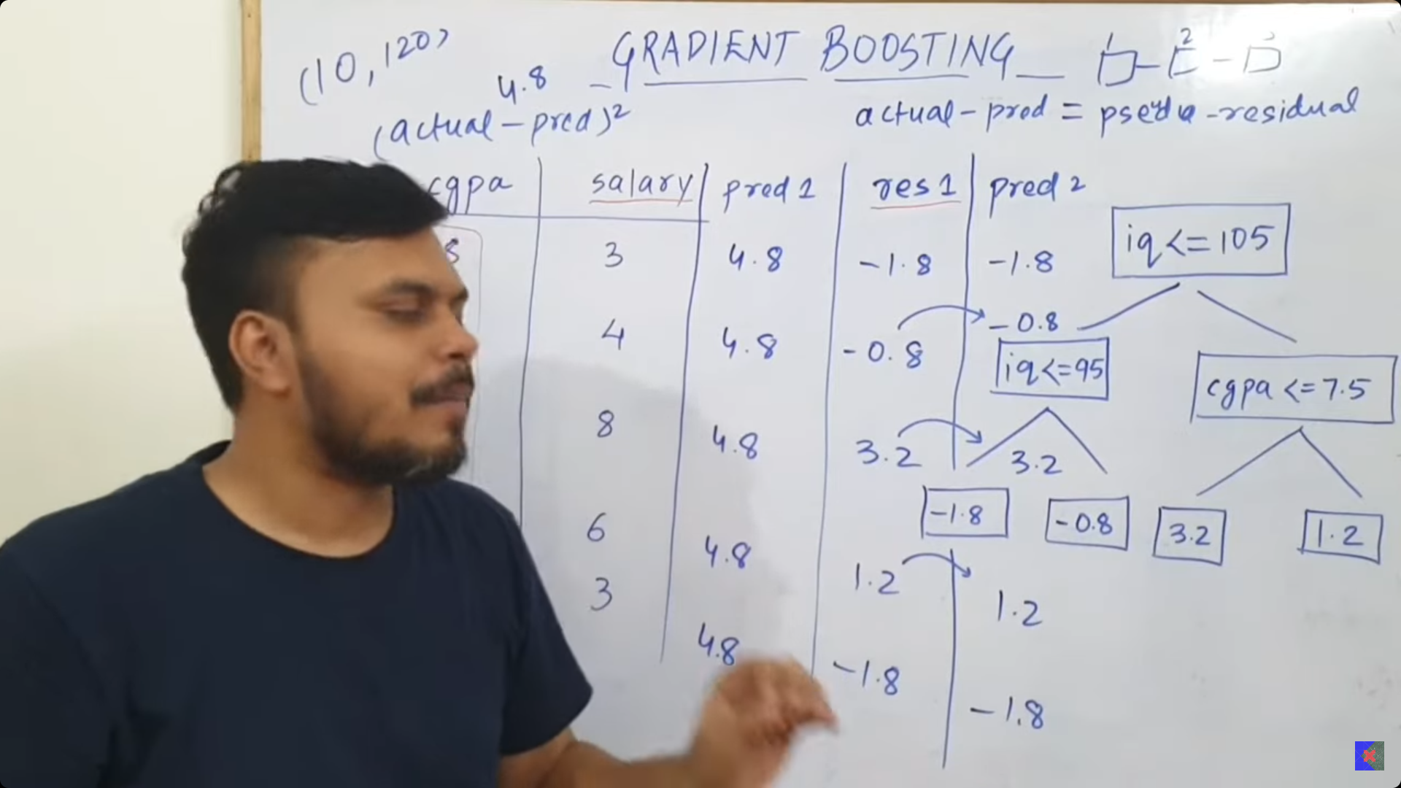

- Prediction = model1 output + model 2 output is the result for the curent.
  - 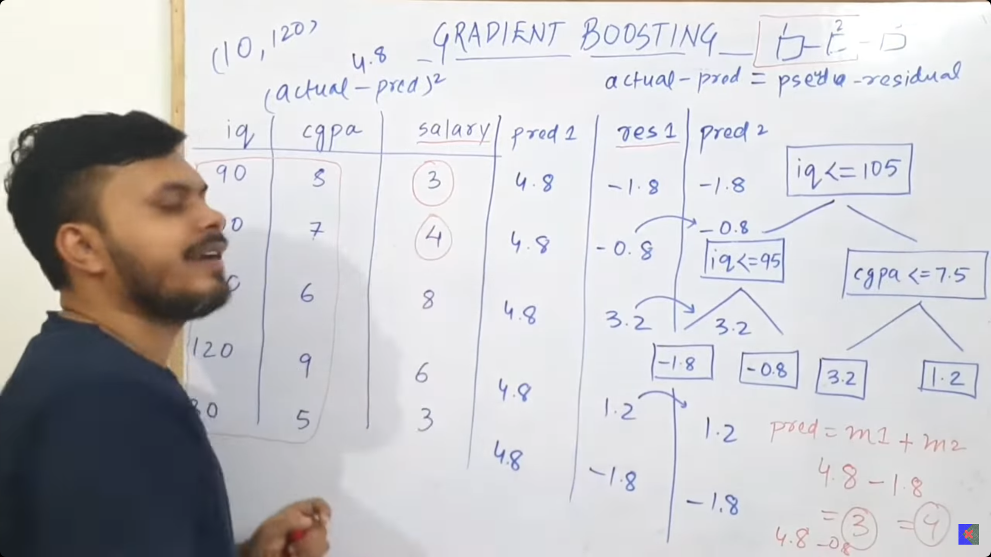
  - The above is overfitting the data, so this is not good for generalisation, so we move on to.
  - prediction = model1+ learning_rate * model 2(for generalisation)
  - 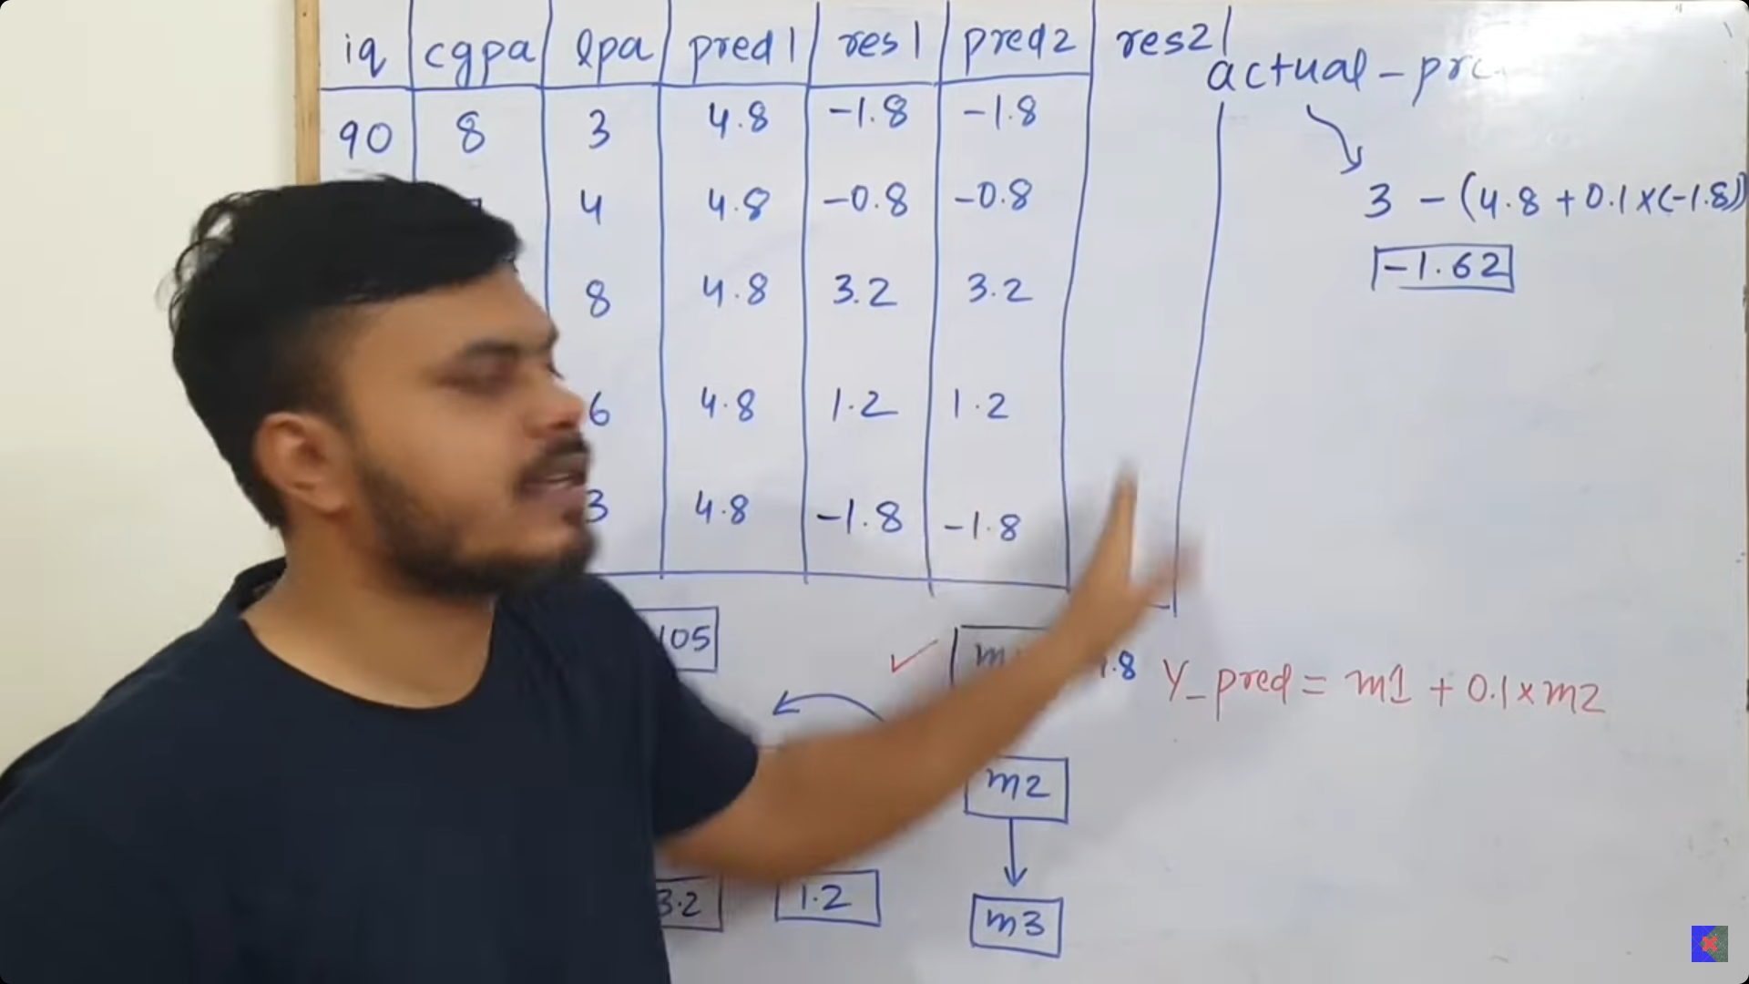
    - prediction = Actual_salary - (output_of_the_model1 + learning_rate * output_of_model2) , output of the model is nothing but prediction done after constructing the decision tree.
  - Remember: The ideal residual should lean towards 0, if residula is 0 then we will have a accurate model prediction.
  - 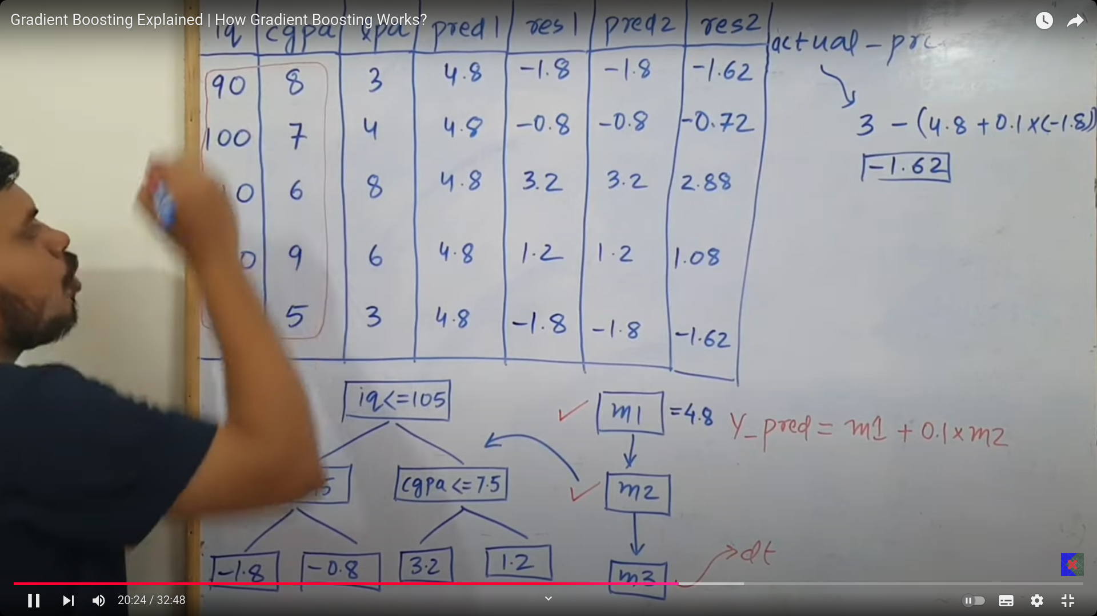
- Model 3(Decision Tree):
  - Input is iq and cgpa and residue of model 2 is the output for training data(so called the training error). Based on the training data, the decision tree model is built.
  - The tree built is used for prediction and again this prediction is used for residue calculation for next model generation.
  - The decision tree used for model 3.
  - 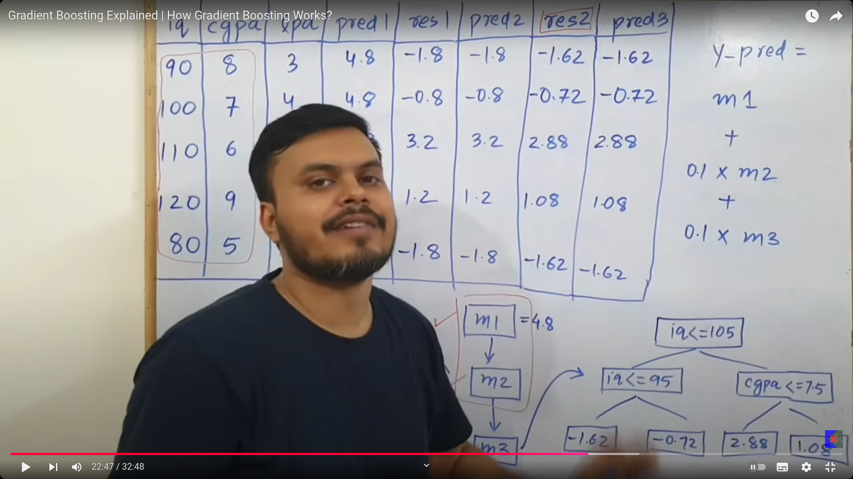
  - learning rate is in my end, so I can alter it in my way.

- The decision stump is with the height is from 8 tiil 32, it works properly, else it wont.
  - 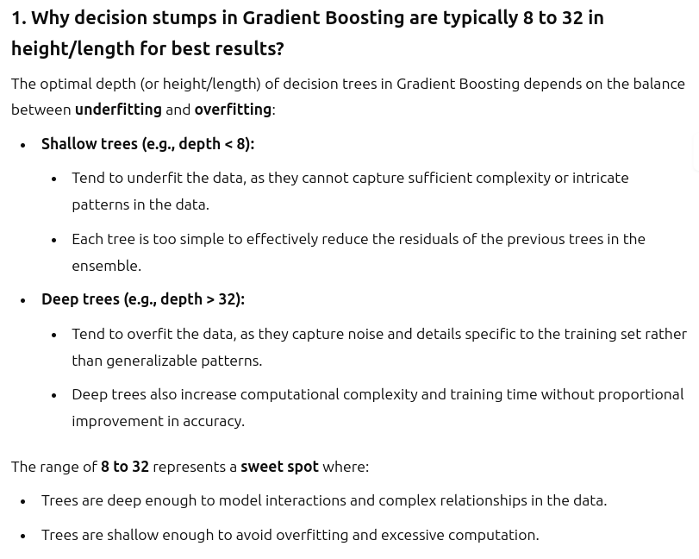
  - 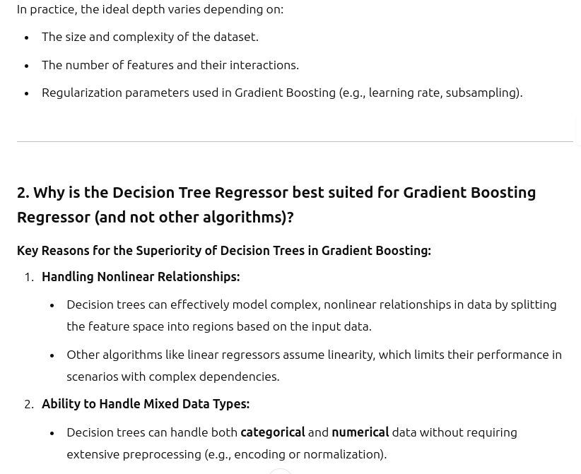
  - 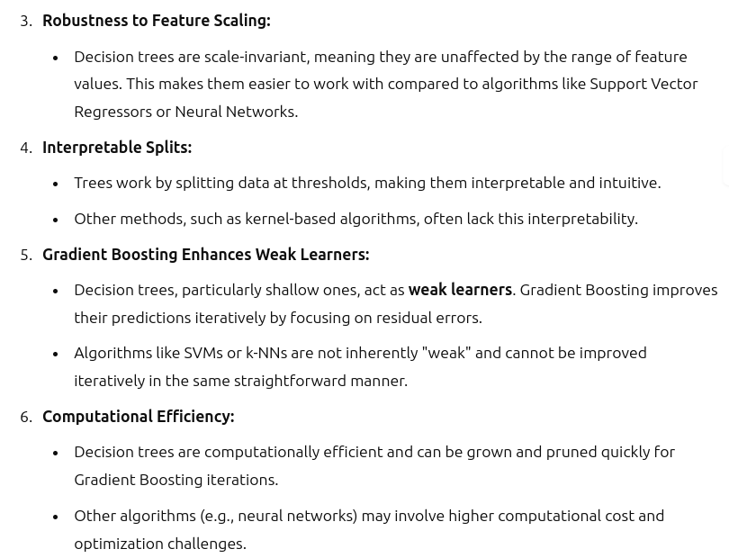
  - 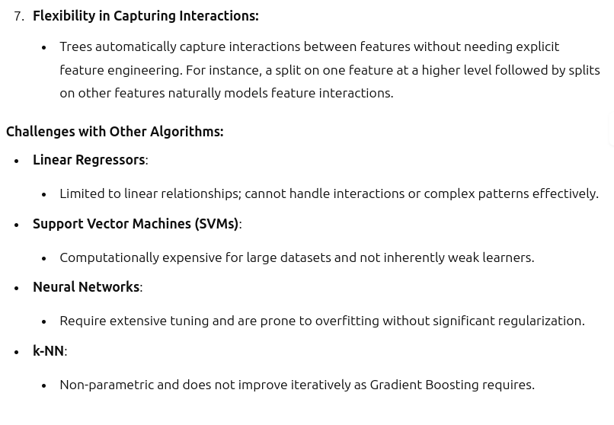
  - 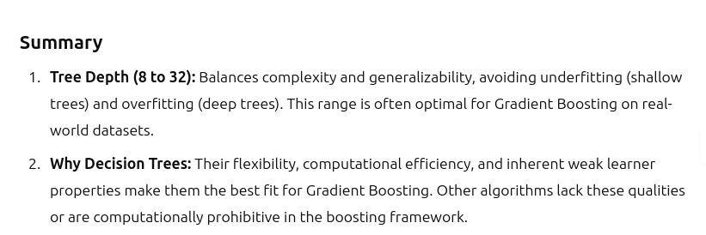

- Gradient Boosting vs Ada Boosting;
  - Decision Tree depth:
    - ada - decision stump, the depth of decision tree -1 .
    - gradient - the decision tree of depth 8 to 32 is needed to make my predictions well .

  - Learning rate:
    - ADA:
      - f= a1b1+a2b2+a3b3
      - a - weight
      - b - models prediction.
      - The output completeley based on the weight we considered.
    - Gradient Boosting:
      - f = m1+ learning_rate * m2+ learning_rate * m3
      - m1 is the average of all the output.
      - m2 - is the model 2’s prediction . m3 - is the model 3’s prediction.
      - learning rate - remains same for all the models output.
      - The above keeps on growing, as the model keeps on adding sequentially.
- All the boosting technique follows stage wise additive modeling.
- Usually in machine learning, we have input and output in term of data, we make a mathematical approximation that fits input and output.
- 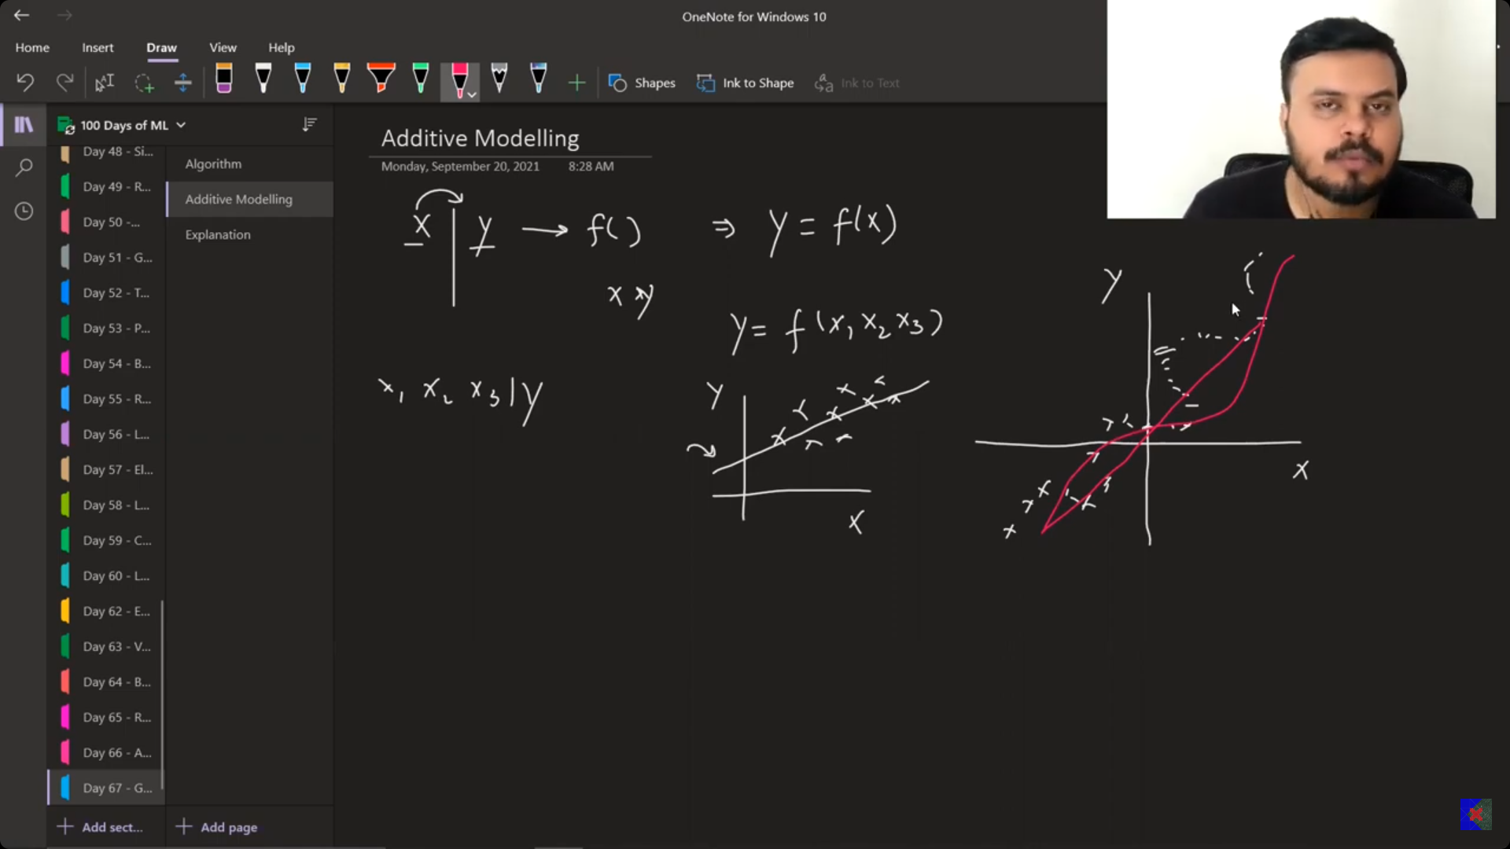
  - The problem with polynomial is runges polynomial:
    - Demonstrates the limitations of polynomial interpolation.
    - States that, when you increase the polynomial degree for the higher levels, then the approximations keeps increases in an abrupt way. such that r2 score of the model reduces to very steep. Hence the we need to move next analysis. Called Additive modeling.
    - 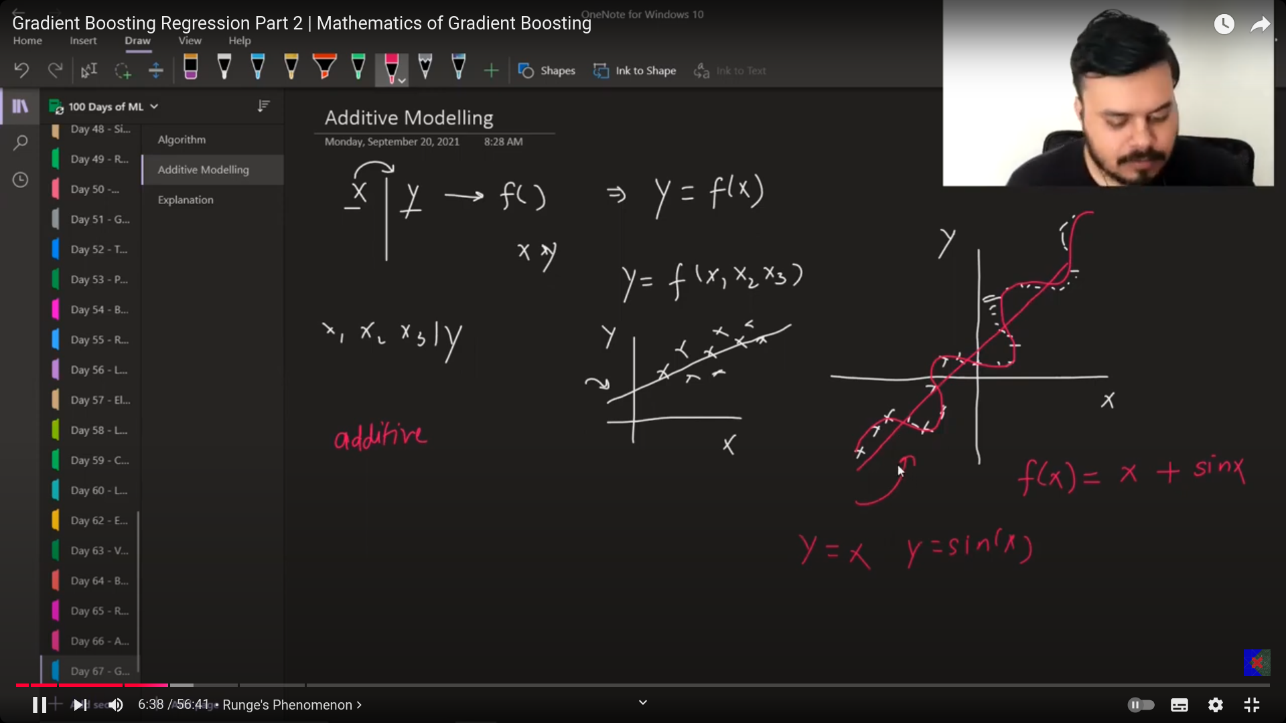
    - desmos/ graphing calculator

- Additive modeling:
  - The large function is a combination of small functions.
  - Such a way that we reach the real function.
  - There will be some functions which cannot be expressed just with the help of simple linear functions and the higher degree polynomial functions.
  - But above , failed can be made successfull with the help of the combination with the linear and non linear function, how to achieve is by making additive function.
  - This additive modeling uses boosting.
  - 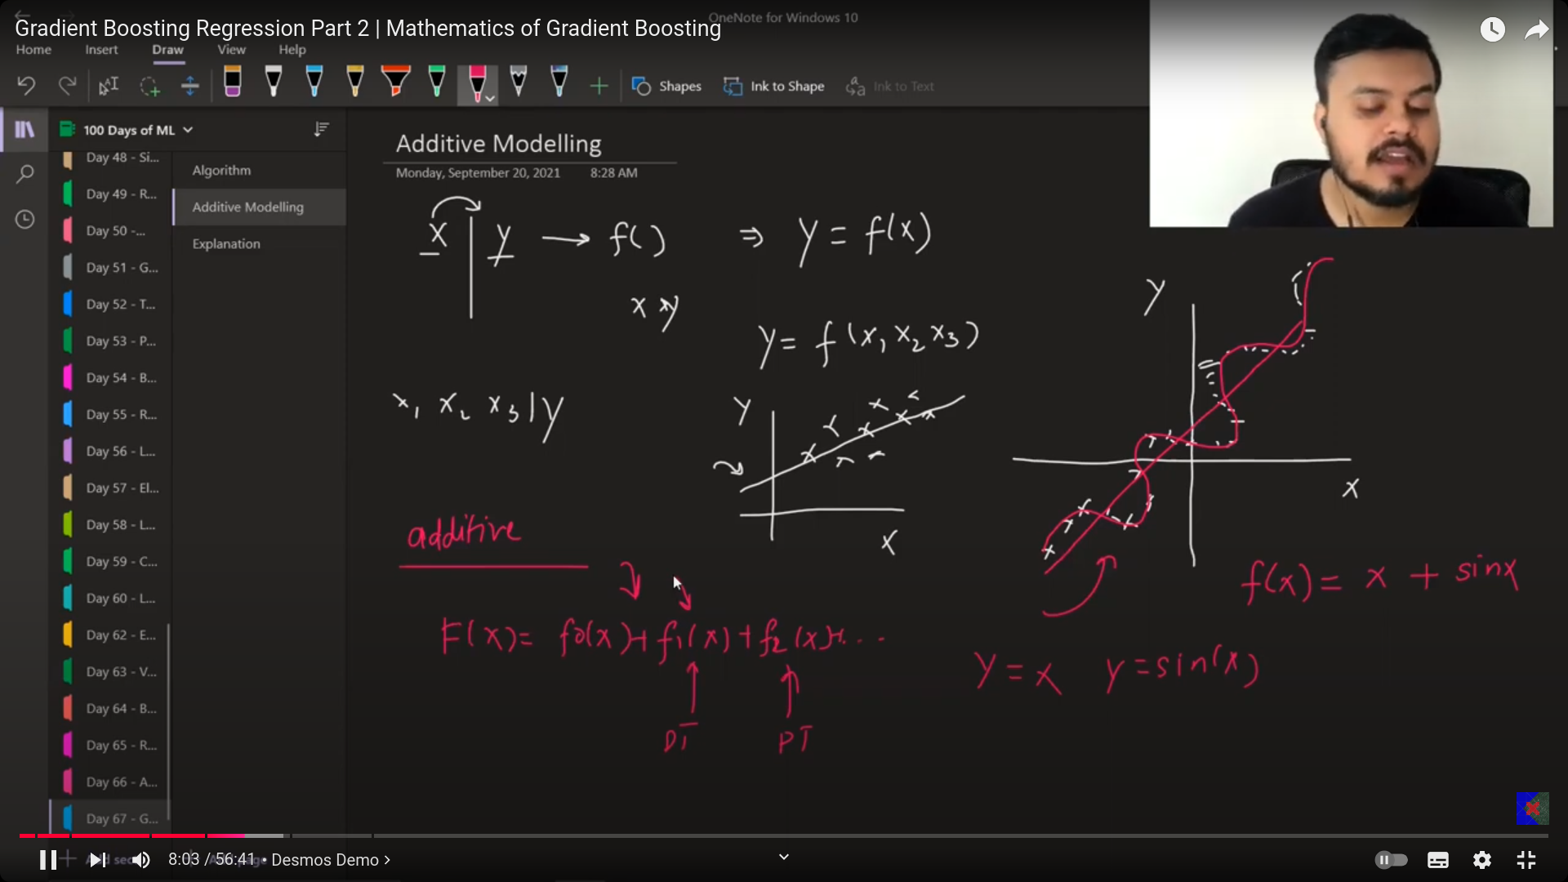

- Relations in machine learning is mathematical function.
- 
- 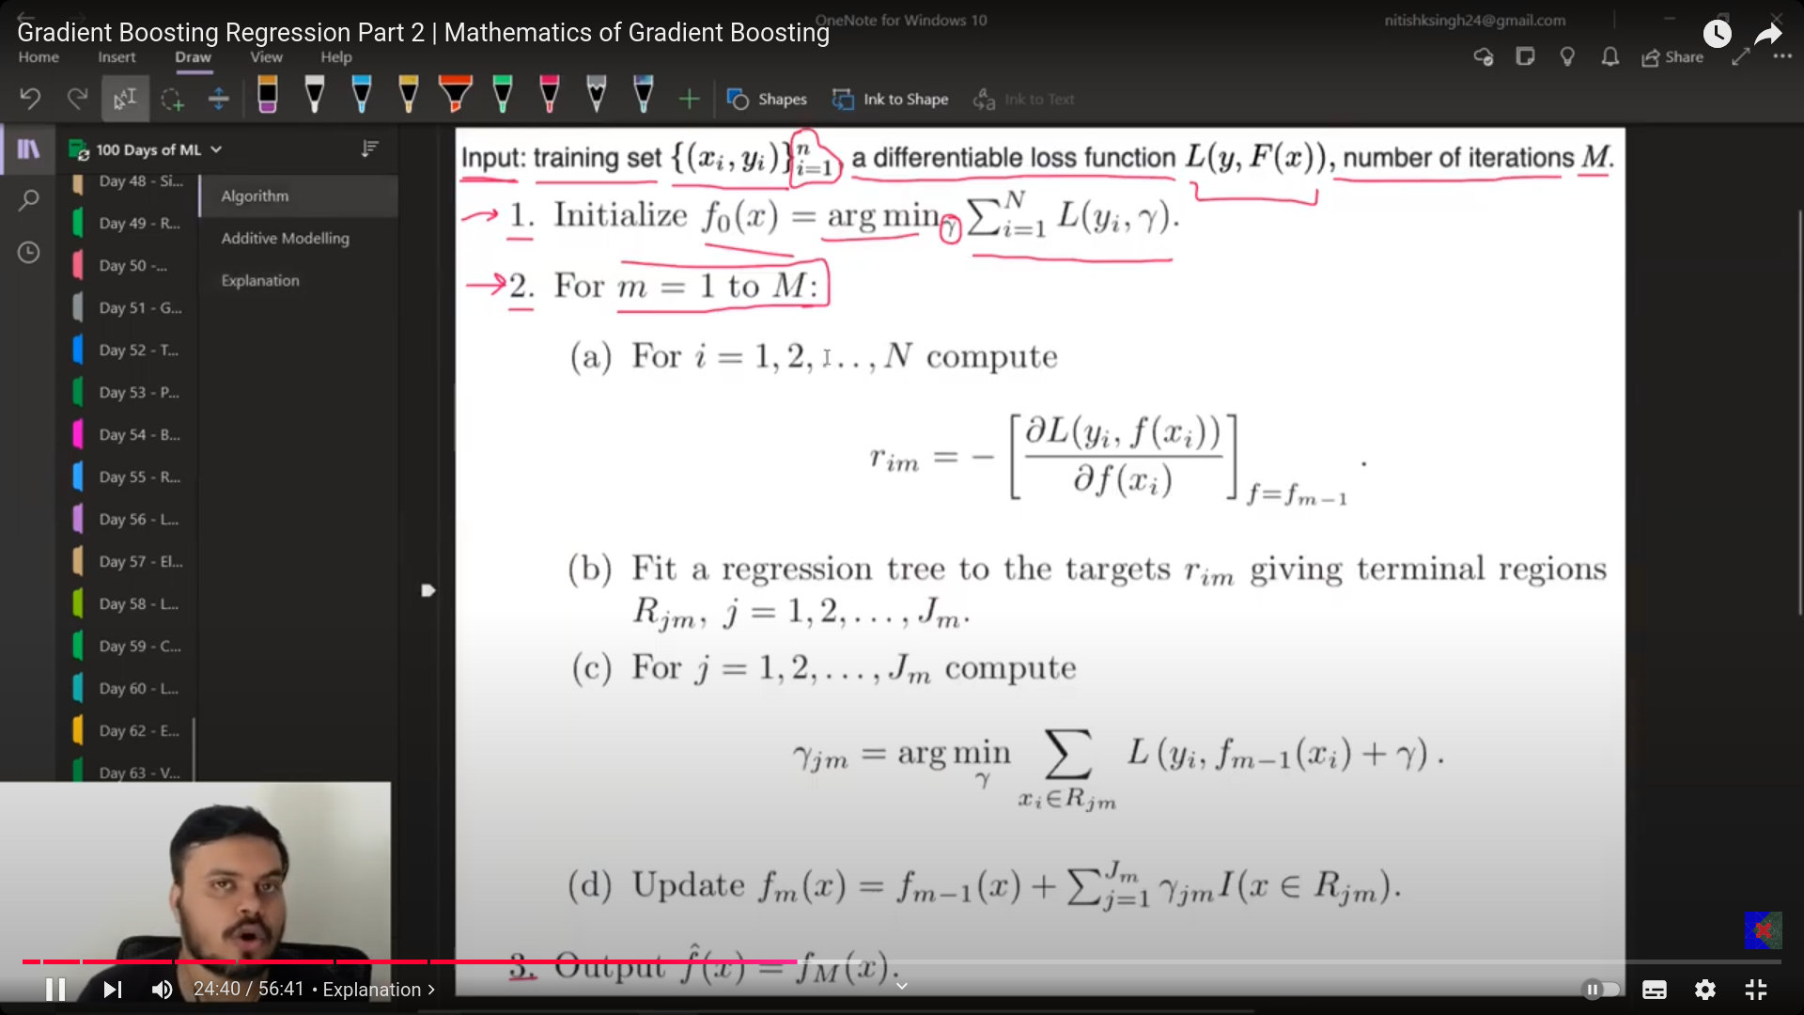
- 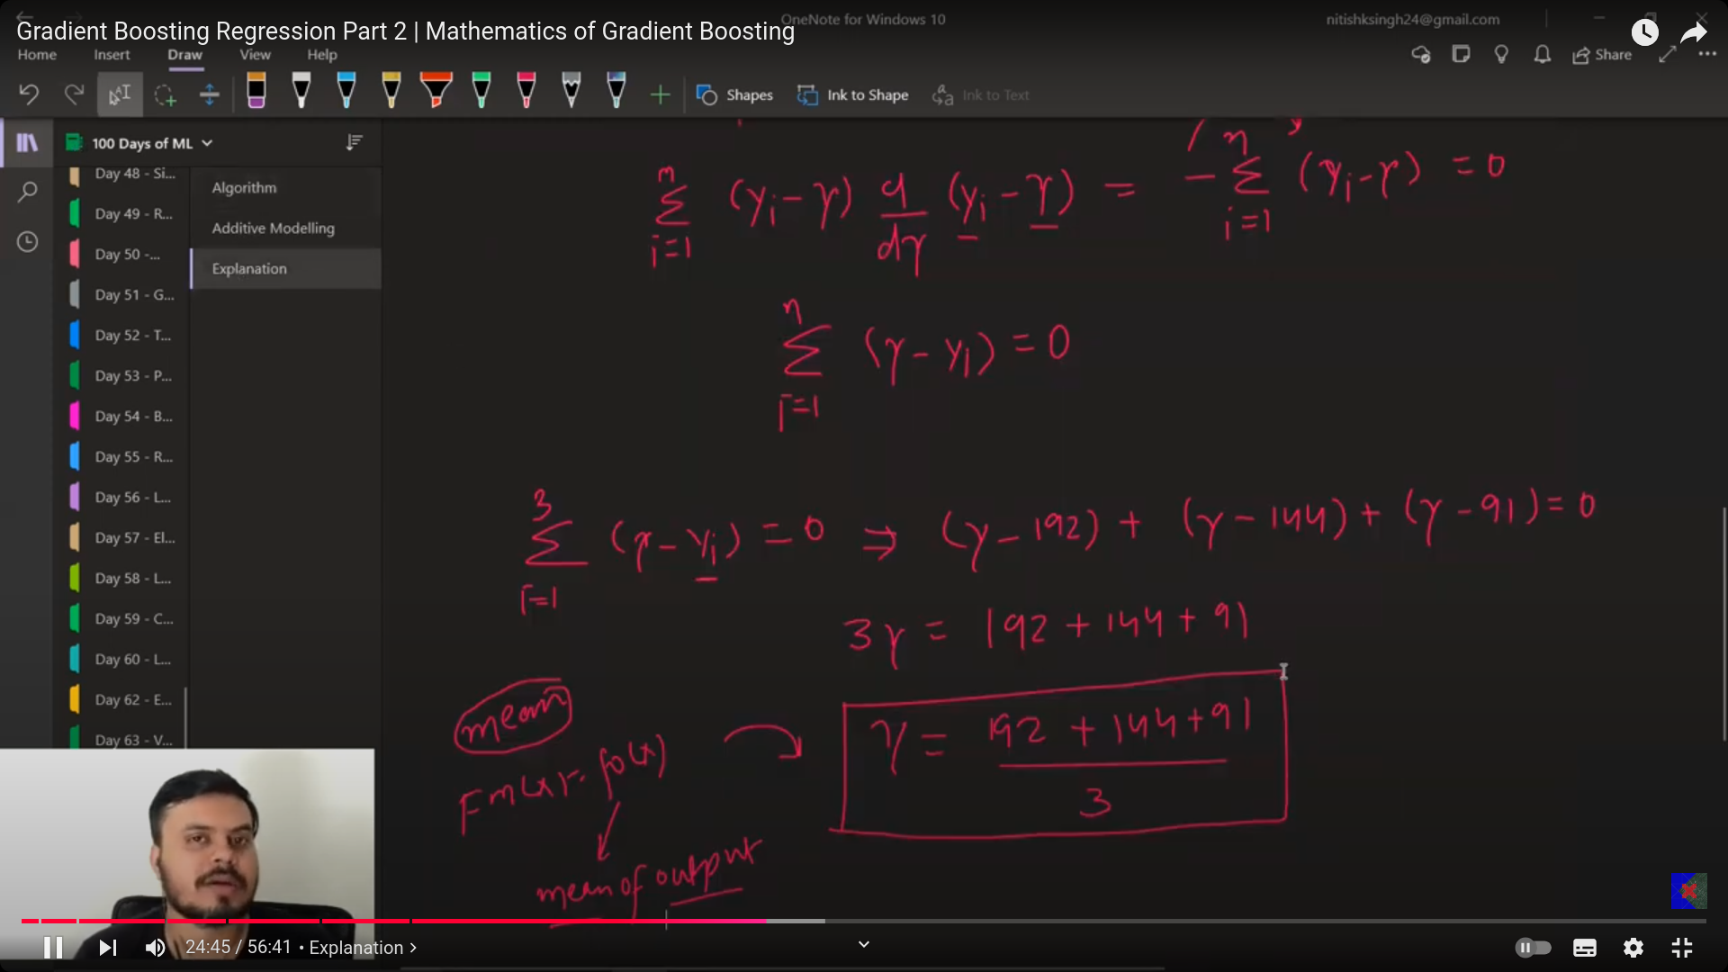
- Summary of Gradient Boosting:
  - The formula for the gradient boosting is:
    - F(x) = model 1_prediction+ learning_rate * model 2 pred+ learning_rate * model 3 pred.
  - Model 1 : For the given dataset, the average of the output is is the prediction of model 1.
    - The we calculate the psuedo residue using formula (output - prediction). The residue tel you the gradient/ direction in which I ahve to move, -ve direction or +ve direction .
  - Model 2 : input data(columns) and along with the residue produced from the above is given as the output, on which the decision tree should build itself and has to predict the output . Now calcuate the residue.

  - Model3: This keeps on growing, each and everytime when the till the formlau estimated number of models .

- Cycle : x-->residue are the input to the next models, i. Hence the process keeps on moving. Hence the model learns everything performs well.
- Code:
- 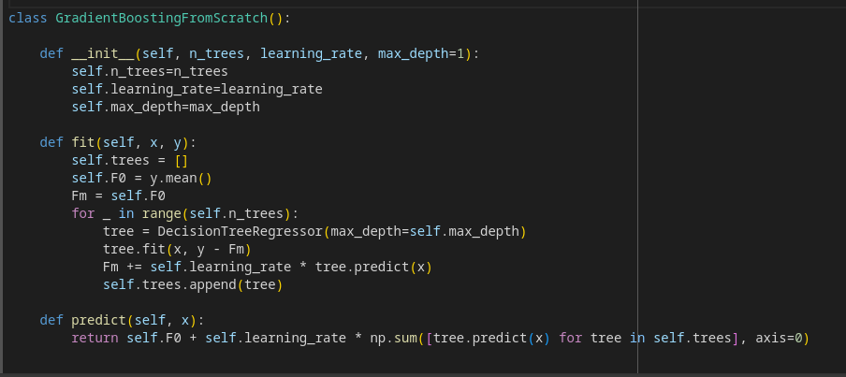
- 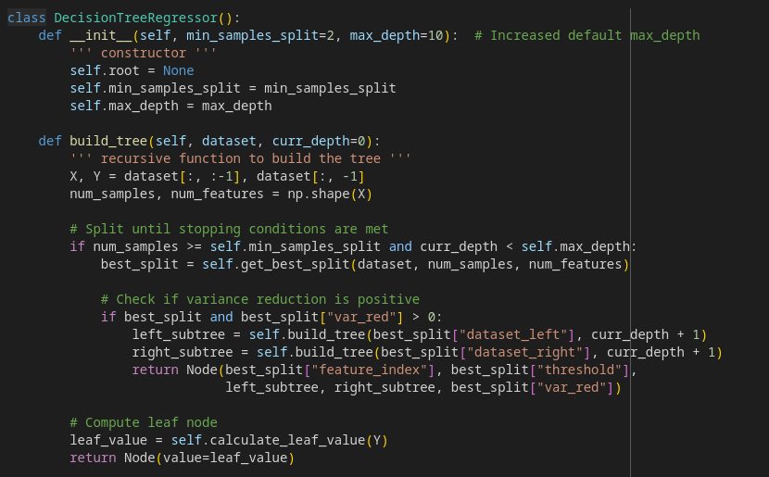
- 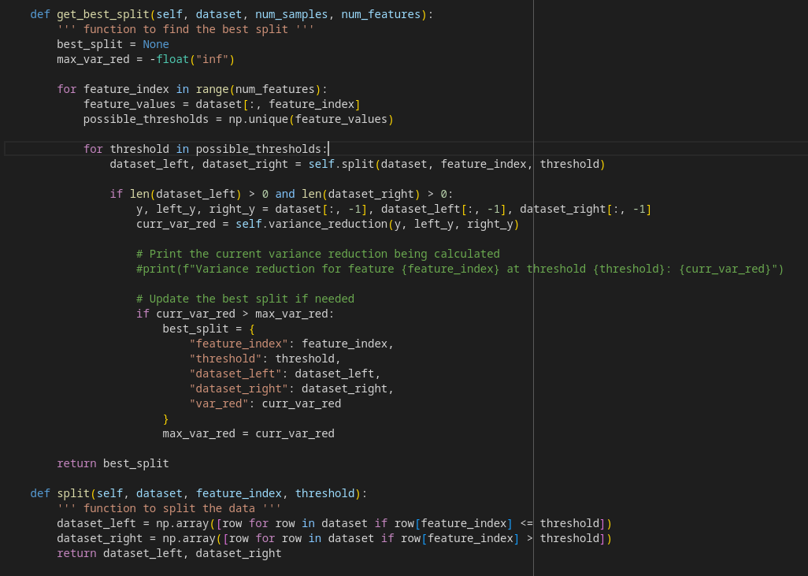
- 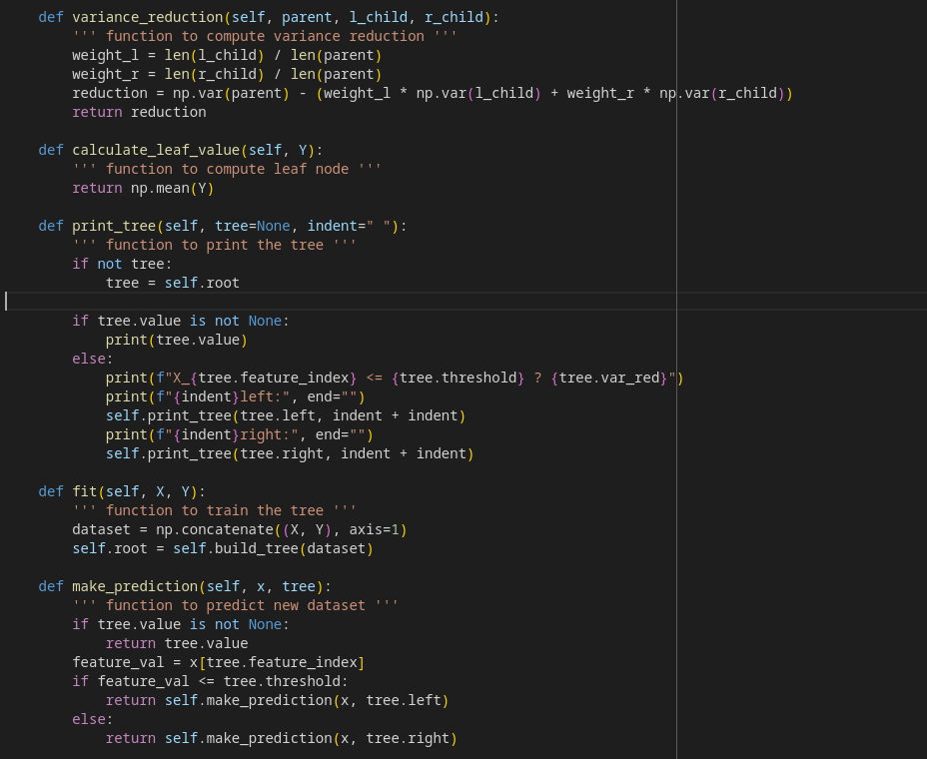
- 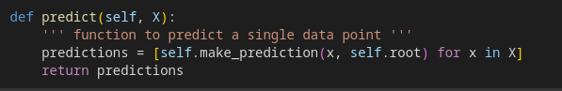

- s

